Missing Birth Weight Analysis Report

Sri Lanka Vital Statistics - IUPAC Compliant Nomenclature
Report Generated: March 24, 2026

1. Executive Summary
This report presents a comprehensive analysis of missing birth weight data in Sri Lanka,
stratified by district and ethnicity. The analysis follows IUPAC (International Union of
Pure and Applied Chemistry) standards for ethnic nomenclature to ensure international
consistency and scientific rigor.
Key Findings:
• Total Records Analyzed: 301,712
• Missing Birth Weight Records: 33,542 (11.12%)
• Complete Records: 268,170 (88.88%)
• Number of Districts Analyzed: 25
• Number of Ethnic Groups Identified: 6

Geographic Distribution of Missing Birth Weight
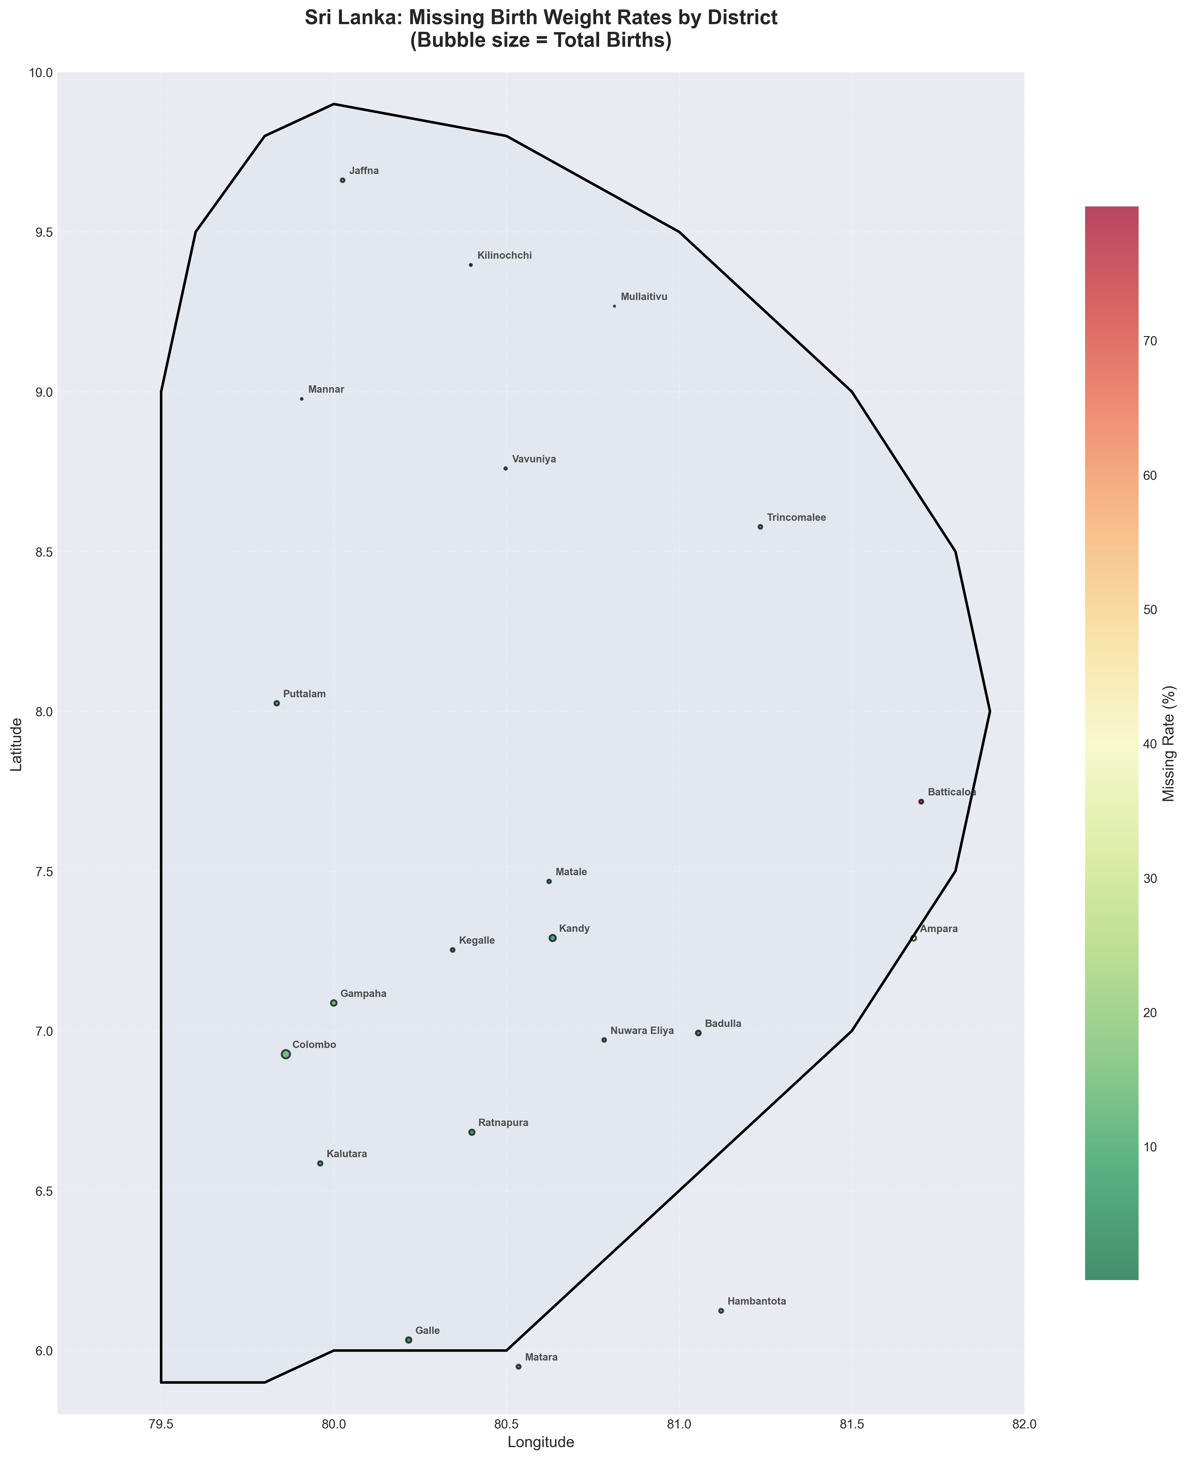
Figure 1: Sri Lankan map showing missing birth weight rates by district. Bubble size represents total birth volume. Red colors indicate higher missing rates.

Province-Level Analysis
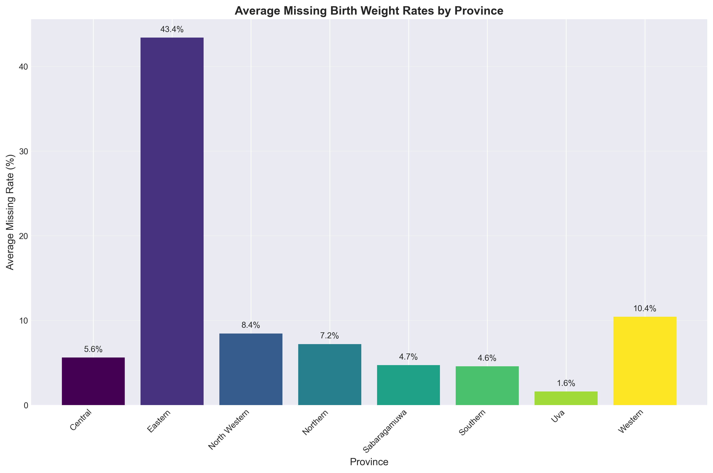
Figure 2: Average missing birth weight rates by province.

Regional Comparison: Northern vs Southern Sri Lanka
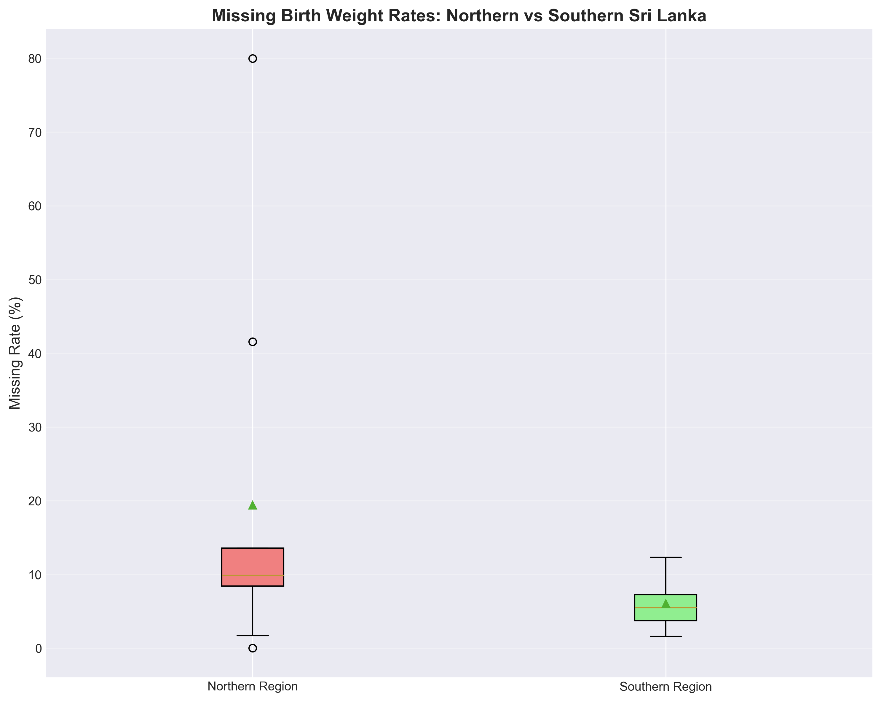
Figure 3: Box plot comparing missing rates between northern and southern regions.

Ethnic Diversity and Missing Rates
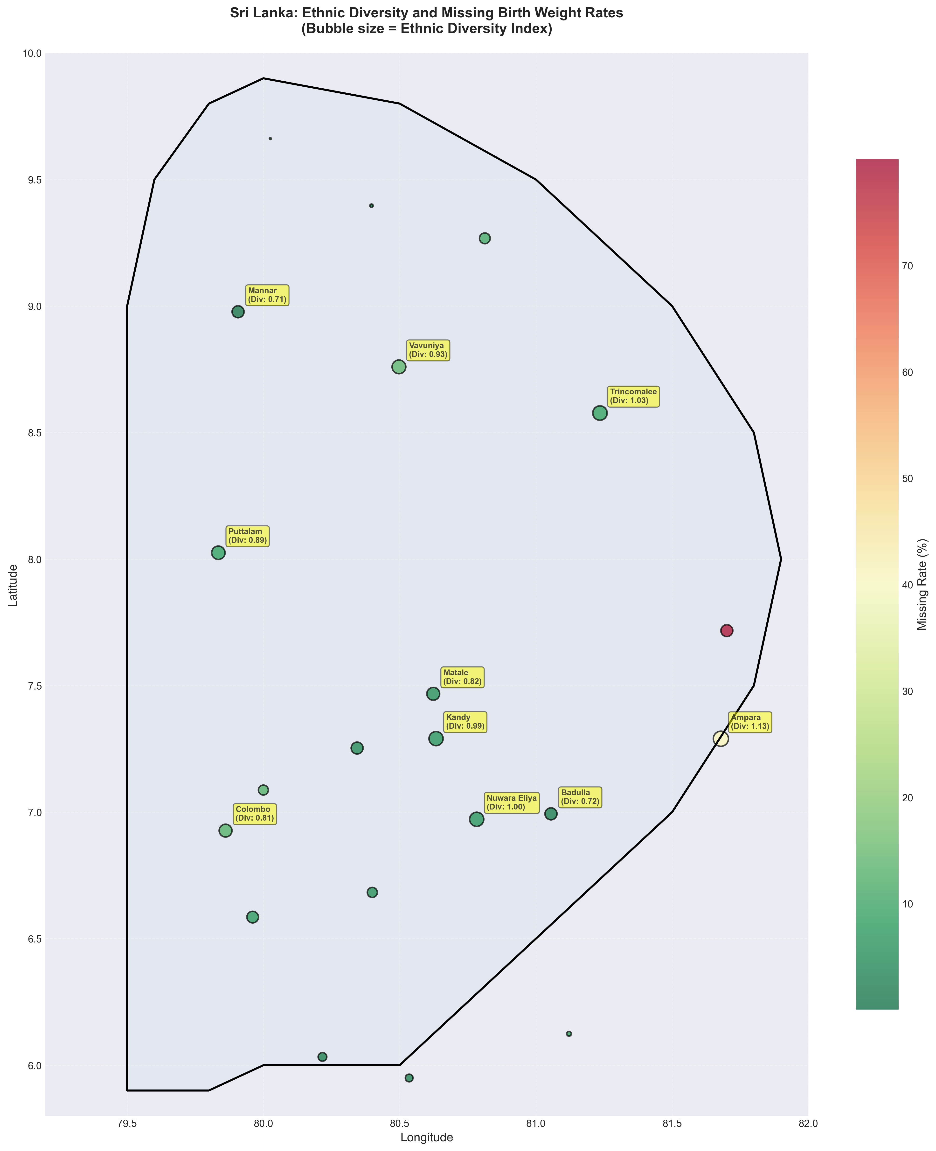
Figure 4: Map showing relationship between ethnic diversity and missing rates. Larger bubbles indicate higher ethnic diversity.

High-Risk Districts
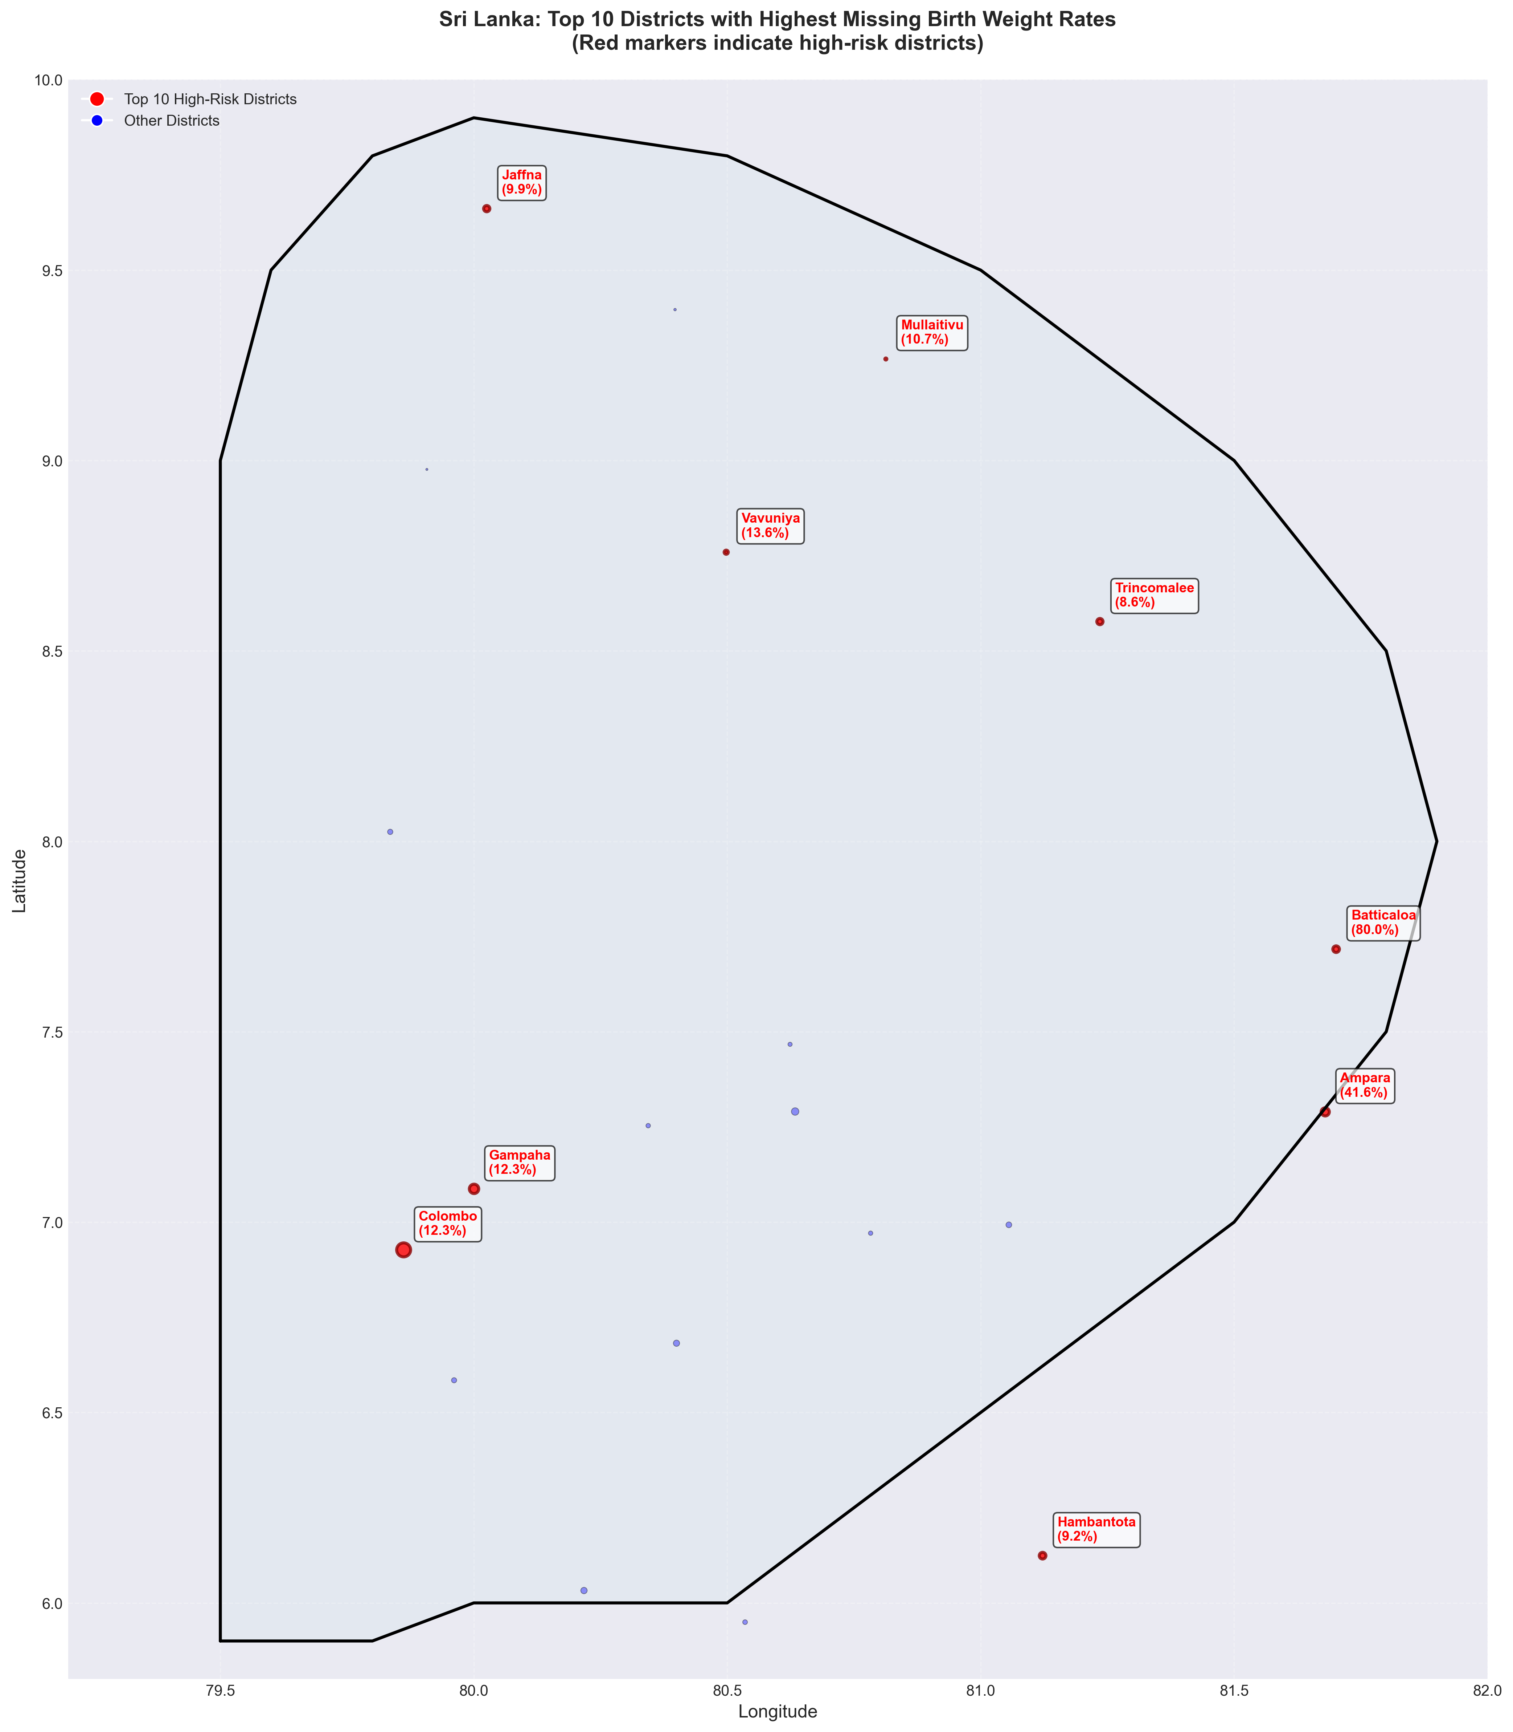
Figure 5: Districts with highest missing rates highlighted in red.

